Regional Operational Plan SF.2A.2019.XX
Operational Plan: Reproductive and Biological Sampling of Yelloweye Rockfish (Sebastes ruberrimus) and Black Rockfish (Sebastes melanops) from Prince William Sound and the Northern Gulf of Alaska
by

Brittany J. Blain
Donald E. Arthur
Adam St. Saviour
Ben Buzzee

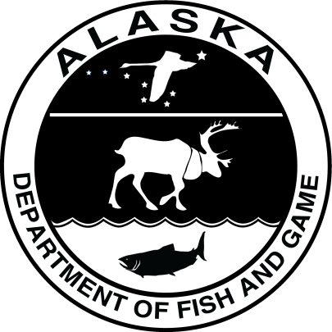
April 2019
Alaska Department of Fish and Game Divisions of Sport Fish and Commercial Fisheries
Symbols and Abbreviations
The following symbols and abbreviations, and others approved for the Système International d'Unités (SI), are used without definition in the following reports by the Divisions of Sport Fish and of Commercial Fisheries: Fishery Manuscripts, Fishery Data Series Reports, Fishery Management Reports, and Special Publications. All others, including deviations from definitions listed below, are noted in the text at first mention, as well as in the titles or footnotes of tables, and in figure or figure captions.

Weights and measures (metric)
centimeter cm
deciliter dL
gram g
hectare ha
kilogram kg
kilometer km
liter L
meter m
milliliter mL
millimeter mm

Weights and measures (English)
cubic feet per second ft³/s
foot ft
gallon gal
inch in
mile mi
nautical mile nmi
ounce oz
pound lb
quart qt
yard yd

Time and temperature
day d
degrees Celsius °C
degrees Fahrenheit °F
degrees kelvin K
hour h
minute min
second s

Physics and chemistry
all atomic symbols
alternating current AC
ampere A
calorie cal
direct current DC
hertz Hz
horsepower hp
hydrogen ion activity pH
(negative log of)
parts per million ppm
parts per thousand ppt,
‰
volts V
watts W
General
Alaska Administrative
Code AAC
all commonly accepted
abbreviations e.g., Mr., Mrs., AM, PM, etc.
all commonly accepted
professional titles e.g., Dr., Ph.D.,
R.N., etc.
at @
compass directions:
east E
north N
south S
west W
copyright ©
corporate suffixes:
Company Co.
Corporation Corp.
Incorporated Inc.
Limited Ltd.
District of Columbia D.C.
et alii (and others) et al.
et cetera (and so forth) etc.
exempli gratia
(for example) e.g.
Federal Information
Code FIC
id est (that is) i.e.
latitude or longitude lat or long
monetary symbols
(U.S.) $, ¢
months (tables and
figures): first three
letters Jan,...,Dec
registered trademark ®
trademark ™
United States
(adjective) U.S.
United States of
America (noun) USA
U.S.C. United States Code
U.S. state use two-letter abbreviations (e.g., AK, WA)
Mathematics, statistics
all standard mathematical
signs, symbols and
abbreviations
alternate hypothesis H_{A}
base of natural logarithm e
catch per unit effort CPUE
coefficient of variation CV
common test statistics (F, t, χ², etc.)
confidence interval CI
correlation coefficient
(multiple) R
correlation coefficient
(simple) r
covariance cov
degree (angular ) °
degrees of freedom df
expected value E
greater than >
greater than or equal to ≥
harvest per unit effort HPUE
less than <
less than or equal to ≤
logarithm (natural) ln
logarithm (base 10) log
logarithm (specify base) log_{2,} etc.
minute (angular) '
not significant NS
null hypothesis H_{O}
percent %
probability P
probability of a type I error
(rejection of the null
hypothesis when true) α
probability of a type II error
(acceptance of the null
hypothesis when false) β
second (angular) "
standard deviation SD
standard error SE
variance
population Var
sample var

Regional Operational plan SF.2A.2019.XX
Operational Plan: Reproductive and Biological Sampling of Yelloweye Rockfish (Sebastes ruberrimus) and Black Rockfish (Sebastes melanops) from Prince William Sound and the Northern Gulf of Alaska

By

xxxxx
Alaska Department of Fish and Game, Division of Sport Fish, Anchorage

Alaska Department of Fish and Game
Division of Sport Fish
333 Raspberry Rd. Anchorage, Alaska 99518-1599
April 2019

The Regional Operational Plan Series was established in 2012 to archive and provide public access to operational plans for fisheries projects of the Divisions of Commercial Fisheries and Sport Fish, as per joint-divisional Operational Planning Policy. Documents in this series are planning documents that may contain raw data, preliminary data analyses and results, and describe operational aspects of fisheries projects that may not actually be implemented. All documents in this series are subject to a technical review process and receive varying degrees of regional, divisional, and biometric approval, but do not generally receive editorial review. Results from the implementation of the operational plan described in this series may be subsequently finalized and published in a different department reporting series or in the formal literature. Please contact the author if you have any questions regarding the information provided in this plan. Regional Operational Plans are available on the Internet at: http://www.adfg.alaska.gov/sf/publications/.

xxxx
Alaska Department of Fish and Game, Division,
333 Raspberry Rd. Anchorage, Alaska 99518-1599

This document should be cited as:
xxxxxxx, 2019. Operational Plan: xxxxxxxx. Alaska Department of Fish and Game, Division of Sport Fish, Regional Operational Plan ROP.SF.2A.2019.X, Anchorage.
The Alaska Department of Fish and Game (ADF&G) administers all programs and activities free from discrimination based on race, color, national origin, age, sex, religion, marital status, pregnancy, parenthood, or disability. The department administers all programs and activities in compliance with Title VI of the Civil Rights Act of 1964, Section 504 of the Rehabilitation Act of 1973, Title II of the Americans with Disabilities Act (ADA) of 1990, the Age Discrimination Act of 1975, and Title IX of the Education Amendments of 1972.
If you believe you have been discriminated against in any program, activity, or facility please write:
ADF&G ADA Coordinator, P.O. Box 115526, Juneau, AK 99811-5526
U.S. Fish and Wildlife Service, 4401 N. Fairfax Drive, MS 2042, Arlington, VA 22203
Office of Equal Opportunity, U.S. Department of the Interior, 1849 C Street NW MS 5230, Washington DC 20240
The department’s ADA Coordinator can be reached via phone at the following numbers:
(VOICE) 907-465-6077, (Statewide Telecommunication Device for the Deaf) 1-800-478-3648,
(Juneau TDD) 907-465-3646, or (FAX) 907-465-6078
For information on alternative formats and questions on this publication, please contact:
ADF&G, Division of Sport Fish, Research and Technical Services, 333 Raspberry Rd, Anchorage AK 99518 (907) 267-2375

Signature Page
Project Title: | Operational Plan: Reproductive and Biological Sampling of Yelloweye Rockfish (Sebastes ruberrimus) and Black Rockfish (Sebastes melanops) from Prince William Sound and the Northern Gulf of Alaska
Project leader(s): | Brittany Blain-Roth, Donald Arthur, Adam St. Saviour
Division, Region, and Area | Sport Fish, Region II, Anchorage Management Area
Project Nomenclature:
Period Covered | 2019–2020
Field Dates: | 2019–2020
Plan Type: | Category II

Approval

Title |  | Name |  | Signature |  | Date
Project leader |  | Donald Arthur
Project leader |  | Adam St. Saviour
Project leader |  | Brittany Blain-Roth
Fisheries Scientist I |  | Katherine Howard
Biometrician |  | Ben Buzzee
Research Coordinator |  | Timothy McKinley

TABLE OF CONTENTS

Page
LIST OF TABLES Iiii
LIST OF FIGURES Error! Bookmark not defined.
abstract 4
Purpose Error! Bookmark not defined.
background 5
Objectives 9
Methods 10
Data Collection and study Design 10
Data Reduction 12
Data Analysis 12
Schedule and Deliverables 13
RESPONSIBILITIES 13
reference cited 15

LIST OF TABLES
Table Page
Table 1.– Age and length-at-maturity for female yelloweye rockfish by location.. Error! Bookmark not defined.6
Table 2.– Macroscopic observation of rockfish ovary for assessment of maturity and development stage 11

abstract

There is a limited understanding of the reproductive biology of yelloweye rockfish (Sebastes ruberrimus) and black rockfish (S. melanops) in Alaskan waters. The purpose of this project is to sample yelloweye rockfish and black rockfish in order to estimate maturity schedules and fecundity (both absolute and relative). An increased understanding of the biological aspects of these rockfish species is an important aspect that is necessary for science-based management, and population dynamics modeling for stock assessment purposes. This project will generate estimates of these important biological parameters, as well as associated parameters e.g., A₅₀ and L₅₀, at the northernmost distribution for these species. Sampling will take place in Prince William Sound and the Northern Gulf of Alaska, including within the state’s North Gulf Coast Management Area.

Key words: Yelloweye Rockfish, Sebastes ruberrimus, Black Rockfish, Sebastes melanops, Prince William Sound, Gulf of Alaska, maturity, gonads, fish condition

Introduction
Recent interdivisional, inter-regional Rockfish Workshops have lead the Alaska Department of Fish and Game (ADF&G) to focus efforts on developing long-term management and stock assessment strategies for black rockfish (Sebastes melanops) and yelloweye rockfish (S. ruberrimus) across the Gulf of Alaska (GOA). During these workshops, reproductive parameters of yelloweye rockfish and black rockfish have been identified as a priority research topic.
Rockfish, in general, grow slowly, mature late, and exhibit low rates of natural mortality (Love et al. 2002). These life history characteristics are more extreme in some rockfish species than others, such as yelloweye rockfish that may not mature until age 22 and can live to over 120 years in age (O’Connell 2002). The northern Gulf of Alaska (GOA), and Prince William Sound (PWS) represent the northernmost distribution of yelloweye rockfish and black rockfish (Mecklenburg et al. 2002), and estimates of maturity schedules are lacking from the area (Haldorson and Love 1991). A latitudinal effect on life history characteristics such as maturity has been documented in a number of fish species, including several rockfish species (Sebastes spp., Haldorson and Love 1991; Redfishes (Sebastes), Ni and Sandeman 1994; Brown Trout, L’Abée-Lund 1991; Eurasian Perch, Heibo 2003; Yelloweye Rockfish and Cabezon, Hannah et al. 2009; Albacore Tuna, Farley et al. 2014, Atlantic Cod, Rose 2018: 251). Consequently, reproductive traits documented in more southerly locations may not be representative of those traits in more northern stocks.
The northern Gulf of Alaska is a dynamic ecosystem that has been observed to undergo regime shifts in species productivity, which can also affect growth and maturation rate (Anderson et al. 1997; Combes et al. 2009; Pozo Buil and Lorenzo 2015, Campbell 2018). Maturity is believed to vary spatially and temporally and can give insight to a stock’s vulnerability to overfishing, since the two are inversely related (Myers and Mertz 1998). Environmental factors and fishing pressure can also influence maturity of a fish population, and these selective pressures can vary with space and time (Trippel 1995; Law 2000; Hutchings 2005).
Length or age at maturity is a fundamental life history parameter that is important to population dynamic modeling and for estimating reproductive potential or spawning stock biomass (Clark 1991; Goodyear 1993). Data corresponding to age at maturity is lacking for yelloweye and black rockfish in their northernmost range and it is an important data gap necessary for management of this species. A graduate study is being conducted to identify age and length at maturity for yelloweye rockfish, in addition to other reproductive parameters. Fish collected in this study will further that work.
Methods for estimating rockfish length or age at maturity have varied throughout their geographical range. For example, some rockfish studies that reported age- or length-at-maturity estimates used outdated and unreliable aging techniques (Wyllie Echeverria 1987); strictly used macroscopic observations to assign maturity (Kronlund and Yamanaka 2001; Yamanaka et al. 2011); or, did not describe the methods that were used to assign maturity status (Rosenthal 1982; Lea et al. 1991; O’Connell et al. 2002). However, studies such as Hannah et al. 2009 have used contemporary methods, which employ the use of histology to assess rockfish age and length at maturity. With an increasing awareness of skip-spawning in rockfish species, there is a consensus that histological methods are preferred over macroscopic methods in order to avoid misidentifying mature fish that are exhibiting skip spawning as immature (Rideout et al. 2005; Rideout and Tomkiewicz 2011; Conrath 2017). The use of histological evaluation of thin-sectioned ovarian tissue (Wyllie Echeverria 1987; Hannah et al. 2009) and sampling during peak ovary development (Westrheim 1975; Gunderson et al. 1980) are believed to decrease error in assigning maturity status to fish.

The overall purpose of this project is to: estimate the length and age maturity schedules for females of both species; document sampling protocols for future collection, identification, preservation, and processing of yelloweye rockfish (Sebastes ruberrimus) and black rockfish (S. melanops) gonads; and, identify the collection of samples that can be related to a population’s reproductive potential (i.e.- age, length, fecundity, fish condition, etc.). Efforts will be divided between inside Prince William Sound waters and Northern Gulf of Alaska waters.

Objectives
Primary Objectives:

- Generate length and age at maturity schedules for black rockfish and yelloweye rockfish for PWS and the NGC.

Secondary Objectives:
- Determine the stage of gonad development using histology sampling.

- Collect yelloweye and black rockfish ovaries to be used for future fecundity analysis.
Task:
- Collect biological data on fish condition including:
  - Length, weight, and age;
  - Liver weights;
  - Tissue samples and;
  - Stomach content samples.

- Collect depth of capture, fishing effort (time), water temperature and other environmental variables.

Methods

Study design and Data Collection

Study Area
As DSF management areas do not clearly define inside and outside waters for PWS, Commercial Fishery Area E statistical areas were assigned to inside, outside and border categories based on expected exposure to coastal ocean currents following ROP SF.4A.2019.01 (Figure 2). Specifically, areas will be divided as follows:
  - Inside waters of PWS
  - Outside waters of PWS–Area E and North Gulf/Cook Inlet Management–Area H

One spatial group will represent inside waters of PWS, and one spatial group will represent neighboring outside waters (Areas E and H) for broad geographic distribution of fish from the Northern GOA. Data will be collected at the border statistical areas that are not being used in ROP SF.4A.2019.01 but they will be lumped with Outside PWS waters. Neighboring statistical areas in Area H (NGC) will provide an additional outside stratum to obtain broad geographic sampling of areas exposed to coastal ocean currents in the vicinity of PWS. Sample will be spread as evenly as possible across this broad area, as is feasible.

Prince William Sound – Inside waters
The inside waters of PWS are characterized by a diversity of coastal habitat that includes glacial fjords, high-relief rocky islands, and tidally influenced bays. They are separated from the GOA by a series of barrier islands, which include the expansive Montague (791 km²) and Hinchinbrook (445 km²) Islands. A number of passages and larger ocean entrances connect PWS to the northern GOA. There are strong tidal currents through most of these passages and entrances, and these large scale transports of water can influence the movement of flotsam and nutrients between PWS and the GOA (Schmidt 1977; Royer et al. 1990; Neibauer et al. 1994; Gay and Vaughan 2001; Vaughan et al. 2001). This transport can also impact the dispersion of planktonic fish such as rockfish larvae, as supported by genetic work that has been performed in the eastern Pacific (Siegle et al. 2013; Andrews et al. 2018).
For the purposes of this study, inside waters of PWS will be defined by statistical areas that are interior to land masses and where little water transport with coastal ocean currents is expected. The inside waters of PWS will be defined as all coastal waters north of lines between Cape Puget and Cape Cleare (southern Montague Is.), Zaikof Point (northeastern Montague Is.) and Cape Hinchinbrook (southwestern Hinchinbrook Is.), and Point Bentinck (southeastern Hinchinbrook Is.) and Point Whitshed (Figure 1). The port towns of Whittier, Valdez, and Cordova, and the native villages Tatitlek and Chenaga are contained within the inside sample area of PWS.

Outside waters – Northern Gulf of Alaska
Outside waters are all waters outside of Prince William Sound and within the northern GOA. The outside waters are comparably more oceanic, and the coastline is noticeably more rugged likely due to erosion from large oceanic swells. Swells in excess of 2 m are not uncommon in the outside waters, and access is limited to larger vessels. The seafloor is flat and mostly comprised of soft sediment in the northern GOA. However, there are intermittent small mounds, rocky reefs, and pinnacles in the Gulf of Alaska that provide habitat for demersal fish species such as rockfish and lingcod. Seal Rocks in Hinchinbrook entrance, Wessel Reef, and rocky outcrops of Middleton Island are well-known rocky habitat in the PWS outer waters. The outside water will be considered any marine water south of the lines previously described out to 370 km. The outside waters of PWS are bounded in the east by a line extending south near Cape Suckling (144°00’00”W) and in the west by a line extending south near Cape Fairfield (148°00’25”W) (Figure map). There are no towns contained within the outside sample area of PWS, yet this area is commonly accessed from the ports of Whittier, Cordova, Valdez, and Seward by the commercial and recreational fishing fleets. Outside waters will extend down into the North Gulf Coast up to Gore Point, the southern end of the North Gulf Coast Management area for the DSF (Figure 3).

Figure 2.–Prince William Sound (Area E) groundfish management area for commercial fisheries, including districts and statistical areas.

Figure 3.–Cook Inlet (Area H) groundfish management area for commercial fisheries, including districts and statistical areas.

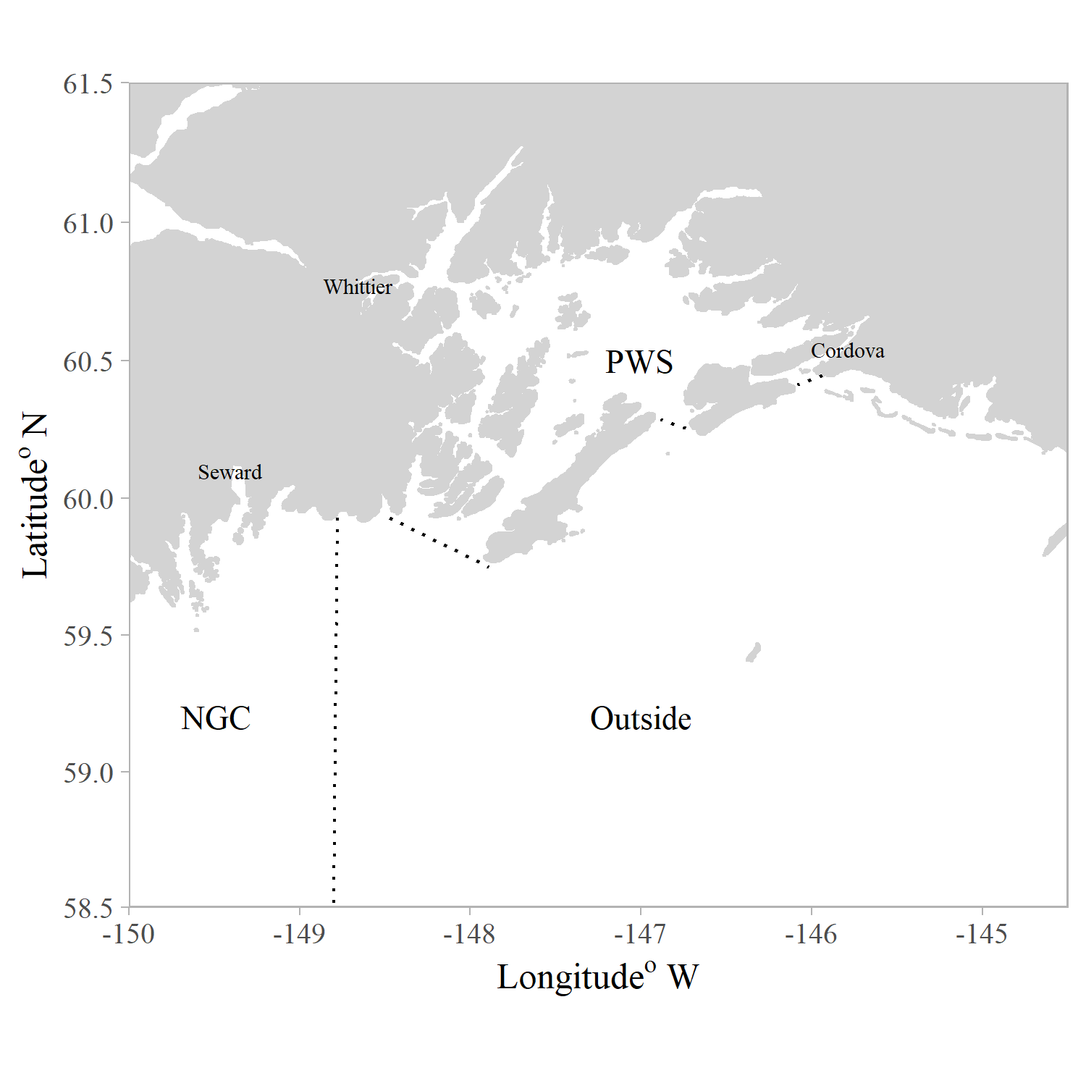
Figure map.- The northern Gulf of Alaska designated sample areas inside of Prince William Sound (PWS), the North Gulf Coast (NGC) and outside of PWS (Outside).

Field Collection
Commercial and sport fishermen who return to ports in and adjacent to PWS (Valdez, Whittier, Cordova, Seward) fish in both inside and outside waters. Yelloweye and black rockfish samples will be collected through field sampling conducted by ADF&G staff. Supplemental collections from the commercial catch and sport port samplers at individual port locations may be collected outside of the target sample size opportunistically.
Yelloweye and black rockfish will be collected on board vessels by hook and line or longline from April 23, 2019 until sample sizes are obtained. Sampling will be opportunistically across the region. Sample collection will be spread spatially throughout the sample areas. Females will be the targeted sex but a subsample of <20% males is expected due to misidentification. Length at 50% maturity is estimated to fall between 37.5-55.0 cm for yelloweye rockfish in PWS based on previous sampling and therefore more samples in these size ranges are preferred. Size goals /bins are outlined below for yelloweye rockfish within length categories:
20% of samples with a length of <40 cm
60% of samples with a length of 40-55 cm
20% of samples with a length >55.1cm
As of April 15, 2019, approximately 85 female yelloweye rockfish have already been collected from inside PWS. No female yelloweye rockfish have been collected from outside PWS. Figure samples 18 shows the distribution of samples collected in 2018.

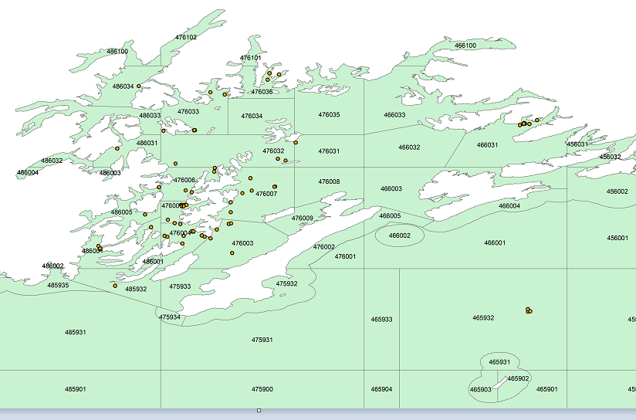
Figure samples 2018.-Dots represent the locations that yelloweye rockfish samples were collected in 2018 for Donald Arthur’s Master Thesis.

Sample Size – Length and Age at Maturity (Objectives 1 and 2)

To assess the precision of our estimates for length and age at maturity and determine appropriate sample sizes, we conducted a series of simulations using the results obtained by Hannah et al. (2009). The simulation consists of the following steps:
- For a given sample size, simulate lengths (ages) from a uniform distribution.
- Using parameter estimates from the logistic regression performed in Hannah et al., simulate maturity status.
- Employing the same techniques described in the data analysis section, create a credible interval for L50 (A50).
- Record the width of the interval in terms of percent of estimate.$\left(percent width=\frac{interval width}{estimate}\right)$

The above procedure was performed 1000 times, and the maximum percent width recorded serves as a reasonable upper bound on the possible width of credible intervals obtained using a given sample size.

After performing the above procedure for both lengths and ages, we conclude that a sample size of 160 female rockfish per sample area, per species will satisfy the precision criteria.

Timing of Collection
Samples will be collected starting in April 2019 and will continue until collected, from each location. Fecundity samples are a secondary objective and will be collected from fish when available.
Field collection will be occur from research vessels using hook-and-line sampling or long line gear. When a target species is caught the following will be documented/occur:
- Record capture depth (m) from the vessel’s depthfinder and GPS location (DDD.DDDD°) from the vessel’s chartplotter at the time that the fish is hooked;
- Record the gear type used to collect the fish;
- For fish that will be retained, a numbered floy-tag or zip-tie will be placed on the dead fish to assign the fish an ID number to pair data and samples for each fish;
- Temperature at depth and at the surface will be collected from each sampling location.

External assessment
All black and yelloweye rockfish caught will have the following external feature data collected immediately following capture regardless of if the fish is being released or retained:
- External barotrauma injuries will be assessed for six external signs of barotrauma: exophthalmia (popeye), distended (tight) abdomen, corneal emphysema, prolapsed cloaca, branchial protrusions, and everted esophageal (stomach) tissue;
- Sex will be identified by the external genitalia (pictures below) and macroscopic observation of the stage of gonads (if applicable; Table ovary);
  - Notes on each fish will be recorded on the datasheet, including if the fish is losing eggs or larvae due to the change of pressure. If loss is occurring, the fish will immediately be placed in a 2-gallon plastic bag or dissected for ovary extraction immediately.
- Fork length (FL) will be measured for each rockfish to the nearest mm using a measuring board.
- If regurgitation is not observed stomach contents will be collected and stored in a zip lock bag, with an identifying tag inside. This request is from Ben Williams (ADF&G Fisheries Scientist I) for future analysis.
- A fin clip for genetic processing will be collected following methods of ROP SF.4A.2019.01. Final samples will be delivered to the ADF&G Genetics lab.

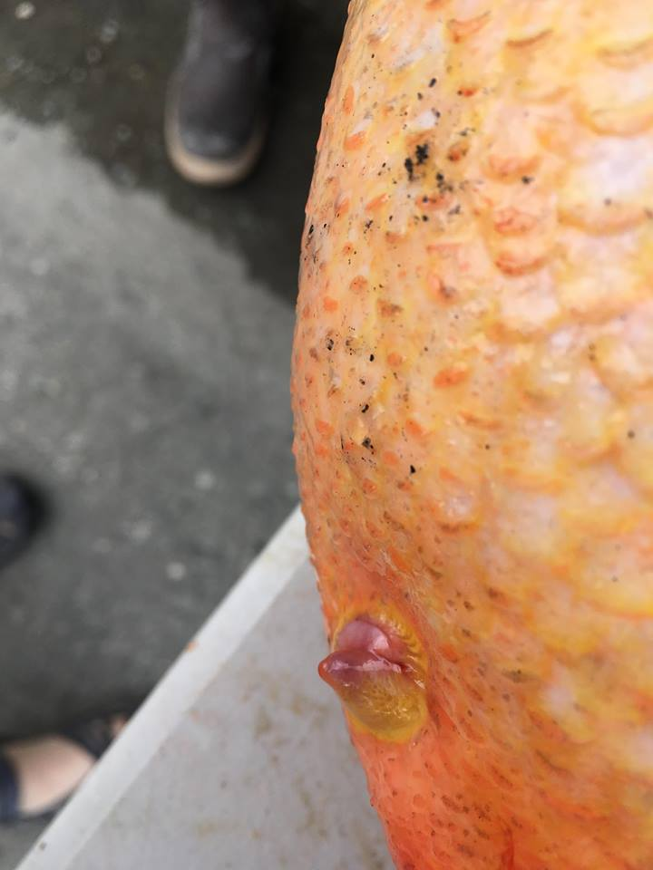 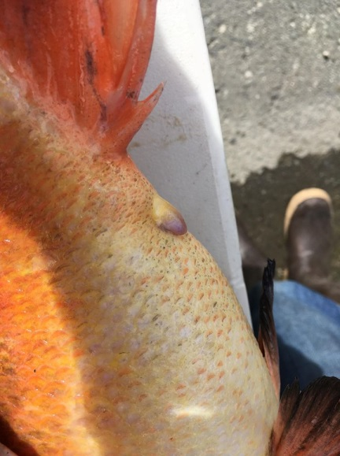\
Female External Genitalia Male External Genitalia
- Plug-like, triangular projection - Elongated projection
- Eggs or larvae sometimes present - Bulbous head
- Large body cavity (not perfect identifier) - Sperm released during spawning (winter
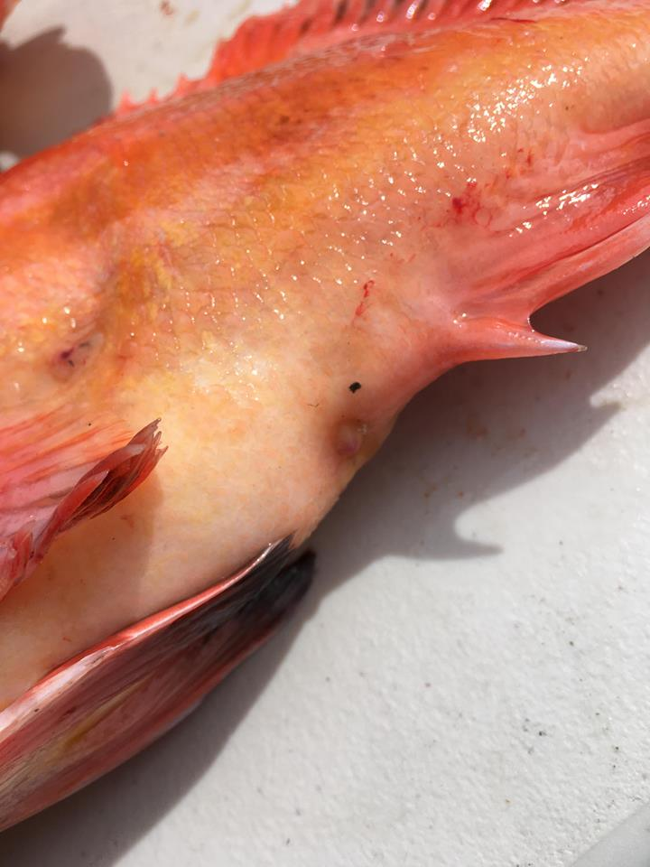
*Unknown*

Table ovary.– Macroscopic observation of rockfish ovary for assessment of maturity and development stage (Westrheim 1975).
 | Stage of Development | Macroscopic Description
1 | Immature | Ovaries small, translucent, and peach or yellow in color.
2 | Maturing (Immature) | Ovaries small to medium, firm, translucent or opaque, yellowish in color.
3 | Mature | Ovaries large, translucent or opaque, yellow in color.
4 | Fertilized | Ovaries large, may be hydrated or loose (not firm), translucent, yellow-orange in color.
5 | Ripe | Ovaries large, hydrated or loose, yellow or gray in color with black dots (presence of eye pigment from embryos or larvae).
6 | Spent | Ovaries medium to large, flaccid, gray, red, or purple in color, residual larvae may be present.
7 | Resting | Ovaries medium, firm, gray-red, dark or black blotches.

Internal assessment/Field processing
If an individual (black or yelloweye rockfish) is going to be killed the fish will be subdued with a concussive blow to the top of the head and have the following data collected:
- Sex will be verified and recorded;
- Weight will be determined to the nearest 0.01kg and recorded;
- Gonad stage will be identified following methods of Westrheim 1975, removed (see methods below), and recorded on the datasheet;
- The liver will be removed, and liver weight will be recorded to the nearest 0.001 kg. (per request from Ben Williams ADF&G Fisheries Scientist I)
- Following liver, organ and gonad removal, fish will be reweighed to determine somatic weight.
- A tissue sample (with no skin) will be collected from the left upper dorsal area of the fish (Figure tissue). The tissue sample will be put in a zip lock bag and frozen for future analysis on a separate project. Samples will be stored with Anchorage DSF staff until project is complete and samples can be sent to the appropriate location for analysis;
- Both otoliths will be removed from each fish. The excess tissue will be removed from the otoliths and they will be stored. Storage vial numbers will be recorded with corresponding fish on data sheet;
- A sample of the stomach contents will be collected whenever possible. The entire stomach and its contents will be removed and stored in a whirl pack and frozen for future analysis. If stomach contents are collected this will be noted on the datasheets. samples will be stored at the Anchorage ADF&G office following collection. (per request from Ben Williams ADF&G Fisheries Scientist I)

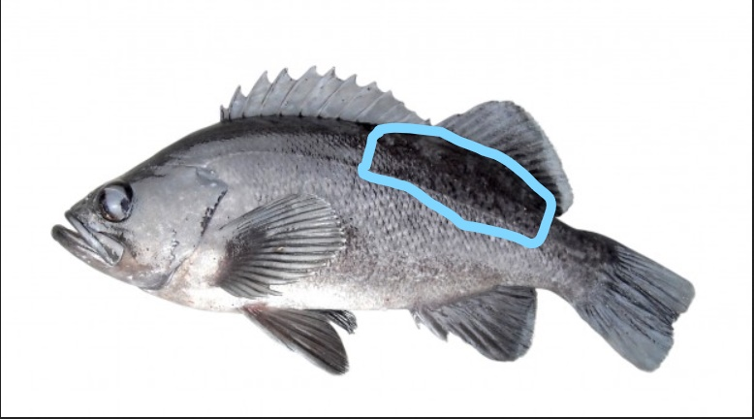
Figure tissue. – Location of tissue sample collection

Gonad identification and removal
An incision will be made from the vent along the ventral side of the fish to remove the gonads. Flesh and skin along the side of the gut cavity will be cut away carefully, exposing the organs. Gonads can be removed by separating the gonads from membranous connective tissue. Gonads must not be punctured. Whole gonads will temporarily be stored in plastic bags labeled with the corresponding fish ID number and chilled in a cooler or refrigerator. The gonads will never be placed directly in contact with ice or in a freezer to avoid cell lysis due to freezing. A photograph will be taken of each set of gonads, and notes describing the potential stage of gonads will be recorded on data sheets. A fresh gonad weight will be collected, whenever possible. The gonads will then be transferred to storage jars and fixed in a glyoxal-based fixative (Glyo-Fixx) with a ratio of 10:1 of fixative to tissue volume.

Data Reduction
For field collected samples, data will be compiled on field datasheets printed on Rite-in-the-Rain paper. The project lead will ensure that all field data is entered in a Microsoft Excel spreadsheet upon return from the field. The fields and data in the Excel file will be set up so that input into R software or OceanAK is easily achieved. A separate datasheet is to be used for data collected in the laboratory such as fecundity, development stage from histology, and fixed ovary weight. This data can be entered into Excel simultaneously as it recorded on the datasheet. The datasheet is simply to act as a back-up for the data. Datasheets will be retained and filed for future data quality control. Storage of data in OceanAK will occur when appropriate.

Data Analysis

Lab Processing/Non-field processing

Gonads – Histology and Fecundity
Ovaries collected will be assessed for maturity (mature=1 and immature=0) and stage of ovary development (Stage 1-7) in the lab. Crude maturity will be assigned based on macroscopic observations using criteria adapted from Westrheim 1975 (Table 2). Histological examinations will be used to validate maturity values and stage of development which will be based on the stage of the most advanced oocyte/embryo described in keys from Bowers 1992 and Bobko and Berkeley 2004.
To prepare histological slides, sections will be prepped from preserved ovaries by embedding them in paraffin wax, thin-sectioned to 5-7µm, and then stained with hematoxylin and eosin Y while on a slide (West 1990, Hannah et al. 2009, Pribyl 2010). All histological preparation will be conducted through Veterinary Services at the University of Alaska Fairbanks. Later, slides will be viewed under a compound microscope. The final determination of maturity and reproductive activity will be assessed from histological observations following the methods of Bowers (1992) and Bobko and Berkeley (2004).

Fecundity
Fecundity will be estimated using the gravimetric method (Murua et al. 2003). Each ovary will be weighed in the lab to produce a fixed total weight (w_{i}) in grams. Three spatial subsamples from each ovary will be used to assess fecundity for each ovary (Bobko and Berkeley 2004). A subsample will be taken from the anterior, interior, and posterior sections of each ovary. Subsamples will be weighed to the nearest 0.001g. Eggs will be spread apart on a gridded petri-dish using a fine brush, and oocytes or embryos for each subsample will be enumerated using an automated particle counter. The number of oocyte or embryos (o_{i}) for each subsample will be divided by the subsample weight (w_{i}) to produce a density of eggs per gram of ovary (dº); see equation 2. Subsamples (n) will continue to be collected until a coefficient of variation (CV) of 5% or less is achieved for the mean density of oocytes or embryos per gram of ovary (Kjesbu 1989, Murua et al. 2003), as shown below in equation 3.

$d^{o}=\frac{\sum_{i=1}^{n}{\left(\frac{o_{i}}{w_{i}}\right)}}{n}$ (2)

$\hat{CV}=\frac{s}{\overline{d^{o}}}*100$ (3)

The mean density will then be multiplied by the total weight of the ovary (W_{o}) to yield an estimate of absolute fecundity (AF), as shown equation 4 from Murua et al. (2003).

$AF=\frac{\sum_{i}{\left[\frac{o_{i}}{w_{i}}\right]}}{n}*W_{o}$ (4)

Absolute fecundity will be estimated for stages 3-5 (mature through ripe) with the possibility that each stage be treated separately in the analysis of fecundity to account for the possibility of fecundity downregulation. Lastly, a relative-fecundity (RF) can be estimated by dividing the absolute fecundity by fish weight (W_{fish}).

$RF=\frac{AF}{W_{fish}}$ (5)

Length and Age at Maturity (Objectives 1 and 2)

The final maturity values from histological examination of black and yelloweye Rockfish will be used to estimate the probability of maturity as a function of length (age). We will perform a Bayesian analysis to obtain estimates and credible intervals for L50 and A50. Maturity status will be modeled as a Bernoulli(p) random variable where:
$p =\frac{1}{1+e^{-\left(β_{o} +β_{1}x\right)}}$ (6)

We will use weakly informative Normal(0, 100) priors for both $β_{0} and β_{1}$. Draws from the posterior distribution of $β_{0} and β_{1}$ will be obtained using Program R (R Core Team 2017) and the rjags package (Martyn Plummer 2016). After obtaining draws for $β_{0} and β_{1}$, draws from the posterior distribution of L50 (A50) will be calculated as:
$L{50}^{*}=\frac{{-β}_{0}}{β_{1}}$ (7)
A 90% central credible interval will be calculated from the posterior distribution. The median of the posterior distribution will be used as our estimate. The model will be fit once using length as the explanatory variable and once using age, resulting in unique estimates and credible intervals for L50 and A50.

Otoliths - ages
Ages will be determined using the break-and-burn method (Chilton and Beamish 1982) by ADF&G Sportfish Division staff in Homer, Alaska.

Hepatosomatic Index (HSI)
As a measure of energy reserves, a hepatosomatic index (HSI) will be calculated following the methods of Busacker et al. (1990). Liver will be removed and weighed. Somatic weight (grams) will be calculated after removing the organs, liver, and ovaries (i.e.-gutted weight):
HSI = (liver weight/somatic weight) x 100

Schedule and Deliverables

Dates | Activity
May 2019 | Prep sampling supplies and vessels.  Sampling trips begin; length will vary from 1–7 days
April 1 – June 30, 2019 | Sampling trips in PWS, Northern GOA; data editing and entry into spreadsheets will occur as the season progresses; histology processing.
July 1, 2019 – June 30, 2020  May 2019 – June 2020 | Donald Arthurs Masters Thesis will be completed in June 2020; All other data collected will be documented in house in a memo or Special publication.  Samples will be processed in the lab.

RESPONSIBILITIES
Brittany Blain-Roth, Fishery Biologist II, Co-Principal Investigator
Duties: Co-author on operational plan. Supervises overall project and data compilation. Edits, analyzes, and reports data.

Donald Arthur, Fishery Biologist I, Graduate Student, Co-Principal Investigator
Duties: Co-author on operational plan and all reports; assists with field work coordination, sampling supplies, and data entry. Writes Master’s thesis and journal articles on yelloweye rockfish.

Adam St. Saviour, Regional Research Biologist, Co-Principal Investigator
Duties: Co-author on operational plan; coordinates NGC sampling schedule and data reporting. Writes report on black rockfish for all areas.

Jay Baumer, Area Management Biologist, Co-Principal Investigator
Duties: Co-author on operational plan and reviews final reports.

Phillip Stacey, Fish and Wildlife Technician III, Crew
Duties: Field work, data entry.

Ben Buzzee, Biometrician
Duties: Provides input to sampling design and operational plan. Provides support during data analysis and reporting.

Tim McKinley, Regional Research Coordinator
Duties: This position reviews the operational plan and the FDS report and assists in obtaining funding for the project.

BUDGET SUMMARY

line
100 |  | $18,000 | OT & sea duty for existing staff
200 |  | $5,000 | Per diem, accommodations, & airfare
300 |  | $52,000 | Vessel charters & histology lab contract
400 |  | $30,000 | Sampling & lab supplies; food
500 |  | $0
Total |  | $105,000

reference cited
Anderson P. J., J. E. Blackburn, and B. A. Johnson. 1997. Declines of forage species in the Gulf of Alaska, 1972-95, as indicator of regime shift. In: Baxter BS (ed) Proceedings of the International Symposium on the Role of Forage Fishes in Marine Ecosystems November 13-16, 1996, Anchorage, Alaska. University of Alaska Sea Grant Rep 97-01: 531-54.
Andrews, K. S., K. M. Nichols, A. Elz, N. Tolimieri, C. J. Harvey, R. Pacunski, D. Lowry, K. L. Yamanaka, and D. M. Tonnes. 2018. Cooperative research sheds light on population structure and listing status of threatened and endangered rockfish species. Conservation Genetics. doi: 10.1007/s10592-018-1060-0.
Blain-Roth, B., J. Baumer, and S. Meyer. 2017. Sport fisheries in the Prince William Sound Management Area, 2014–2016. Alaska Department of Fish and Game, Fishery Management Report No. 17-44, Anchorage.
Berkeley, S.A., C. Chapman, and S. Sogard. 2004. Maternal age as a determinant of larval growth and survival in a marine fish, Sebastes Melanops. Ecology: 85:5:1258-1264.
Bobko, S. J. and S. A. Berkeley. 2004. Maturity, ovarian cycle, fecundity, and age- specific parturition of Black Rockfish (Sebastes melanops). Fishery Bulletin 102(3): 418-429.
Bowers, M.J. 1992. Annual reproductive cycle of oocytes and embryos of Yellowtail Rockfish Sebastes flavidus (family Scorpaenidae). U.S. National Marine Fisheries Service Fishery Bulletin 90:231–242.
Busacker, G.P., I.R. Adelman, and E.M. Goolish. 1990. Growth. Pages 363-387 In C.B. Schreck and P.B. Moyle, editors. Methods for fish biology. American Fisheries Society, Bethesda, Maryland. Clark, W.G. 1991. Groundfish exploitation rates based on life history parameters. Can. J. Fish. Aquat. Sci. 48: 734-750.
Campbell, R. W. 2018. Hydrographic trends in Prince William Sound, Alaska, 1960-2016. Deep Sea Resarch Part II: Topical Studies in Oceanography, 147: 43-57.
Chilton, D.E., and R.J. Beamish. 1982. Age determination methods for fishes studied by the Groundfish Program at the Pacific Biological Station. Can. Spec. Publ. Fish. Aquat. Sci. 60, 102.
Clark, W. G. 1991. Groundfish exploitation rates based on life history parameters. Can. J. Fish. Aquat. Sci., 48: 734-750.
Combes, V., E. Di Lorenzo, and E. Curchitser. 2009. Interannual and decadal varitations in cross shelf transport in the Gulf of Alaska. Journal of Physical Oceanography, 39: 1050-1059.
Conrath, C.L. 2017. Maturity, spawning omission, and reproductive complexity of deepwater rockfish. Transactions of the American Fisheries Society 146(3):495–507.
Dempson, J. B., V. A. Braithwaite, D. Doherty, and M. Power. 2010. Stable isotope analysis of marine feeding signatures of Atlantic salmon in the North Atlantic, ICES Journal of Marine Science, Volume 67, Issue 1: 52–61, https://doi.org/10.1093/icesjms/fsp227
Dick, E.J., S. Beyer, M. Mangel, and S. Ralston. 2017. A meta-analysis of fecundity in rockfishes (genus Sebastes). Fisheries Research 187:73–85. Elsevier B.V.
Echeverria, T.W. 1987. Thirty-four species of California rockfishes: maturity and seasonality of reproduction. Fishery Bulletin 85(2):229–250.
Farley, J. H., S. D. Hoyle, J. P. Eveson, A. J. Williams, C. R. Davies, and S. J. Nichol. 2014. Maturity ogives for South Pacific Albacore Tuna (Thunnus alalunga) that account for spatial and seasonal variation in the distributions of mature and immature fish. PloS One 9, e83017.
Gay III, S.M. and S. L Vaughan. 2001. Seasonal hydrographyand tidal currents of bays and fjords in Prince William Sound, Alaska. Fisheries Oceanography. 10(1): 159-193.
Goodyear, C. P. 1993. Spawning stock biomass per recruit in fisheries management: foundation and current use. In Risk Evaluation and Biological Reference Points for Fisheries Management, 120: 67–81.
Gunderson, D. R., P. Callahan, and B. Goiney. 1980. Maturation and fecundity of four species of Sebastes. Mar. Fish. Rev. 42:74-79.
Haldorson, L. and M. S. Love. 1991. Maturity and Fecundity in Rockfishes, Sebastes spp, a Review. Marine Fisheries Review 43(2): 25-31.
Hannah, R.W., M.T. Blume, and J.E. Thompson. 2009. Length and age at maturity of female yelloweye rockfish (Sebastes rubberimus) and cabezon (Scorpaenichthys marmoratus) from Oregon waters based on histological evaluation of maturity.
Heibo, E. 2003. Life-history variation and age at maturity in Eurasian Perch (Perca fluviatilis L.). PhD thesis. Swedish University of Agricultural Sciences, Umea.
Hutchings, J. A. 2005. Life history consequences of overexploitation to population recovery in Northwest Atlantic cod (Gadus morhua). Canadian Journal of Fisheries and Aquatic Sciences, 62: 824 –832.
Kjesbu, O. S. 1989. Oogenesis in cod, Gadus morhua L., studied by light and electron microscopy. Journal of Fish Biology, 34: 735-746.
Kronlund, A.R., and K.L. Yamanaka. 2001. Yelloweye Rockfish (Sebastes ruberrimus) Life History Parameters Assessed from Areas with Contrasting Fishing Histories. Page Spatial Processes and Management of Marine Populations.
L'Abée‐Lund, J.H. 1991. Variation within and between rivers in adult size and sea age at maturity of anadromous brown trout, Salmo trutta. Canadian Journal of Fisheries and Aquatic Sciences 48:1015–1021.
Lambert, Y., and J-D. Dutil. 1997. "Can simple condition indices be used to monitor and quantify seasonal changes in the energy reserves of cod (Gadus morhua)?." Canadian Journal of Fisheries and Aquatic Sciences 54.S1: 104-112.
Law, R., 2000. Fishing, selection and, phenotypic evolution. ICES J. Mar. Sci., 57: 659–668.
Lea, R. N., R. D. McAllister, and D. A. Ventresca. 1999. Biological aspects of nearshore rockfishes of the genus Sebastes from Central California. California Department of Fish and Game, Fisheries Bulletin 177.
Love, M., Yoklavich, M., Thorsteinson, L. 2002. The Rockfishes of the Northeast Pacific. University of California Press.
Matley, J. K., G. E. Maes, F. Devloo‐Delva, R. Huerlimann, G. Chua, A. J. Tobin, A. T. Fisk, C.A. Simpfendorfer, and M. R. Heupel. 2018. "Integrating complementary methods to improve diet analysis in fishery‐targeted species." Ecology and evolution 8-18: 9503-9515.
Mecklenburg, C.W., T.A. Mecklenburg, and L.K. Thorsteinson. 2002. Fishes of Alaska. Am.
Fish. Soc., Bethesda, MD.

Murua, H., G. Kraus, F. Sabrido-Rey, P. R. Witthames, A. Thorsen, and S. Junquera. 2003.
Procedures to estimate fecundity of marine fish species in relation to their reproductive Strategy 33: 33-54.

Myers, R. A., and Mertz, G. 1998. The limits of exploitation: a precautionary approach. Ecol.
Appl. 8(1): 165–169.

Neibauer, H. J., T. C. Royer, and T. J. Weingartner. 1994. The circulation of Prince William
Sound, Alaska. Journal of Geophysical Research, 99: 14113-14126.

Ni, I-H, and E. .J. Sandeman. 1984. Size at maturity for Northwest Atlantic redfishes (Sebastes).
Can. J. Fsh. Aquat. Sci. 41: 1753-1762.

O’Connell, V.M, C. Brylinsky, and D. Carlile. 2002. Demersal Shelf Rockfish Stock Assessment
for 2003. Alaska Department of Fish and Game IJ02-44: 419-458.

Pozo Buil, M. and E. Di Lorenzo. 2015. Decadal changes in Gulf of Alaska upwelling source
waters, Geophys. Res. Lett. 42: 1488–1495.
Plummer, M. (2016). rjags: Bayesian Graphical Models using MCMC. R package version 4-6. https://CRAN.R-project.org/package=rjags
R Core Team. 2017. R: A language and environment for statistical computing. R Foundation for Statistical Computing, Vienna, Austria. URL https://www.R-project.org/.
Rideout, R. M., G. A. Rose, and M. P. M. Burton. 2005. Skipped spawning in female iteroparous fishes. Fish and Fisheries 6: 50–72.
Rideout, R. M., and J. Tomkiewicz. 2011. Skipped spawning in fishes: more common than you
might think. Marine and Coastal Fisheries: Dynamics, Management, and Ecosystem Science
[online serial] 3: 176–189.
Rose, G., editor. 2018. Atlantic Cod: A Bio-Ecology. John Wiley & Sons, Hoboken NJ.
Royer, T. C., J. A. Vermersch, T. J. Weingartner, H. J. Niebauer, and R. D. Muench. 1990. Ocean
circulation influencing the Exxon Valdez oil Spill. Oceanography 3(2): 3-10.

Rumble, J., E. Russ, C. Russ, and M. Byerly. 2017. Prince William Sound Registration Area E
groundfish fisheries management report, 2014–2017. Alaska Department of Fish and Game,
Fishery Management Report No. 17-40, Anchorage.

Schmidt, G. M. 1977. The exchange of water between Prince William Sound and the Gulf of
Alaska. Master’s thesis. University of Alaska Fairbanks. Fairbanks, AK.

Siegle, M. R., E. B. Taylor, K. M. Miller, R. E. Withler, and K. L. Yamanaka. 2013. Subtle population genetic structure in yelloweye rockfish (Sebastes ruberrimus) is consistent with a major oceanographic division in British Columbia, Canada. PLoS ONE. 8(8): e71083.

Trippel, E. A. 1995. Age at maturity as a stress indicator in fisheries: biological processes related
to reproduction in Northwest Atlantic groundfish populations that have undergone declines.
Bioscience, 45(11): 759-771.

Vaughan, C. L., C. N. K. Mooers, and S. M. Gay. 2001. Physical variability in Prince William Sound during the SEA Study (1994–98). Fisheries Oceanography, 10(1): 58-80.

von Biela, Vanessa R., Seth D. Newsome, and Christian E. Zimmerman. 2015. "Examining the utility of bulk otolith δ13C to describe diet in wild-caught black rockfish Sebastes melanops." Aquatic Biology 23.3: 201-208
Westrheim, S.J. 1975. Reproduction, maturation and identification of larvae of some Sebastes (Scorpaenidae) species in the northeast Pacific Ocean. Journal of the Fisheries Research Board of Canada 32:2399–2411.
Wyllie Echeverria, T. 1987. Thirty-four species of California rockfishes: maturity and seasonality of reproduction. Fisheries Bulletin, 85: 229-250.
Yamanaka, K.L., M.K. Mcallister, P.F. Olesiuk, S.G. Obradovich, and R. Haigh. 2011. Stock
Assessment for the inside population of yelloweye rockfish (Sebastes ruberrimus) in British
Columbia, Canada for 2010. Fisheries and Ocean, Canada 129.

Appendix
Table yellas.– Literature values of age and length-at-maturity for female yelloweye rockfish by location.
Location |  | Sample Size  (n=) | Age-at-Maturity  A₅₀ (years) | Length-at-Maturity  L₅₀ (cm) | Source
N. and Central Californiaª | 132 |  | 7 | 40 | (Wyllie Echeverria 1987)
N. and Central California | 23 |  | 8-9 | -- | (Lea et al. 1999)
Oregon | 158 |  | 11.6 | 38.8 | (Hannah et al. 2009)
Vancouver Island^{b} Outside (B.C.) | 88 / 204 |  | 16.5 / 17.2 | 42.1 / 42.4 | (Kronlund and Yamanaka 2001)
Vancouver Island Inside (B.C.) | 455 |  | 17.68 | -- | (Yamanaka et al. 2011)
Queen Charlotte^{b} Island (B.C.) | 123 / 107 |  | 18.9 / 20.3 | 48.5 / 49.1 | (Kronlund and Yamanaka 2001)
CSEO^{ac} Southeast Alaska | 51 |  | 14-15 | 41 | (Rosenthal et al. 1982)
SEO^{d} Southeast Alaska | 892 |  | 22 | 41.8 | (O’Connell et al. 2003)
a- Surface-aging of otoliths, as opposed to the break-and-burn technique.
b- Two separate areas sampled; sample sizes and estimates are reported separately for both sites.
c- Central Southeast Outside
d- Southeast Outside District

Table blacks.- Literature values of age and length-at maturity for female black rockfish by location.
 | L₅₀ (cm) | A₅₀ (yrs) | Source
Central and Northern California¹ | 36/41 | 6/7 | Wyllie Echeverria, 1987
Oregon² | 39.4 | 7.5 | Bobko and Berkeley, 2004
Oregon (Depoe Bay)¹ | --- | 5/6 | McClure 1982
Washington¹ | 21/33 | 3/3-4 | Barker 1979
Southeast AK  Gulf of Alaska¹ | 40/39 | 9-10/9-10 | Rosenthal et al. 1982  (only available in print at UAF and Juneau libraries)
Southeast AK  Gulf of Alaska² | --- | 10-11 | Field 1984³
1 Male/Female
2 Female only
3 Cannot find direct source; it is Field’s Thesis work. Cited by Carrie Worton et al. 2003.

Example datasheet for field collection

Data Sheet Description
Reproductive Biology Datasheet
Fish Number- Assigned by tagging with floy tag after the Black or Yelloweye Rockfish has been dispatched and weighed.
Species- Black or Yelloweye Rockfish; possibly lingcod in the future.
Genetic Vial Number- Genetic Collection and Vial Number (ex.- YERPWS19 #001).
Date- Date of capture for each specimen in format mm/dd/yyyy
Time- Time of capture for each specimen in 24-hr format (hhmm)
STAT Area- The groundfish Stat Code for the location of capture. (only use this when GPS coordinates are not available)
Lat./Long.- The GPS Coordinates for the location of capture in decimal degrees (ddd.ddddd).
Depth of Capture- The depth of capture for each specimen according to the depth reported by the sonar; try to avoid relying on line counting reels.
Fish Number (second time)- Same as above; to pair capture information (front page) with biological information (back page).
Sex- Male (M), Female (F), or Unknown (U); sex determination should be made prior to dissections, DO NOT CORRECT after dissection has been completed.
Macroscopic Maturity Stage- Staging based on keys provide prior to fixation
FL (mm)- Fork Length for each specimen to the nearest mm
Total (kg)- Whole/Total fish weight to the nearest 0.01kg.
Gutted (kg)- Fish weight after the removal of gonads, liver, stomach, and other intestines to the nearest 0.01kg.
Gonad (g)- The prefixed weight of ovaries or testes for each fish to the nearest 0.001g for gonads <300g and 0.1 for gonads >300g.
Liver (g)- The weight of the liver for each fish to the nearest 0.001g for livers <300g and 0.1 for livers >300g.
Otolith Plate Location- Plate and well number for otolith storage in 48-deep well plate (ex.- Plate 1 B2).

These dates are tentative and will change based mostly on weather in Prince William Sound.

